TROLLEY WHEEL LOAD DATA

Hoist 1

1 General
Hoist load (SWL) 5 000 kg
Hoisting height 6,0 m [max 6,00 m]
Hoist type SH 4012-20 4/1 L2
Hoist group M5
Trolley traversing duty group M5
Hoisting speed 5/0,83 m/min 2-speed
Trolley traversing speed 20/5 m/min 2-speed
Dynamic coefficient for live load 1,19
Dynamic coefficient for dead load 1,10
Sideways pull factor 1,05
Weight of hoist and trolley 330 kg

2 Wheel load drawing
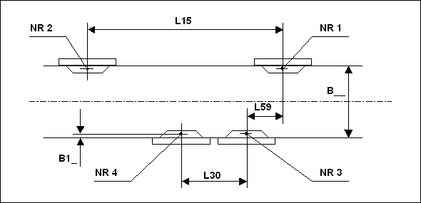

3 Wheel load data

Distance between trolley wheels (L15) 570 mm
Distance between trolley wheels (L30) 570 mm
Distance between trolley wheels (L59) mm
Girder flange width (B__) 260 mm
Trolley wheel contact point from flange edge (B1_) 18 mm

Static Wheel load (load+trolley /trolley only) (NR1) 1 498 kg / 99 kg
Static Wheel load (load+trolley /trolley only) (NR2) 1 649 kg / 66 kg
Static Wheel load (load+trolley /trolley only) (NR3) 1 498 kg / 99 kg
Static Wheel load (load+trolley /trolley only) (NR4) 1 649 kg / 66 kg

Dynamic Wheel load (load and trolley wgt.) (NR1) 17,2 kN
Dynamic Wheel load (load and trolley wgt.) (NR2) 19,4 kN
Dynamic Wheel load (load and trolley wgt.) (NR3) 17,6 kN
Dynamic Wheel load (load and trolley wgt.) (NR4) 19,4 kN

